The Customer

The customer is an integral part of any design process. The partnership between you and your client is how you determine the end goal of your project. The customer has a set of wants and needs for their project and it is your job to ascertain and mimic these to the best of your ability. The client may have unexpressed expectations or assumptions and a good designer will be able to draw these out through interviews and meetings.

But it’s tough work being the client, too! In this assignment, you are to be the customer and the teachers will be your designers. It is your goal to get your designer to understand your needs and get the teacher to output a product that matches your desires.

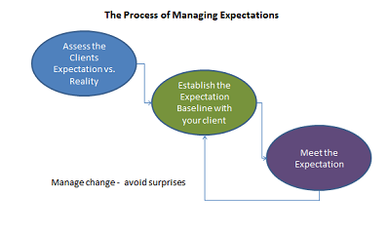

Steps:
- Choose: your intended product from the list.
- Initial Meet: with your designer. You will be interviewed about your product and your goals.
- Observation: Watch your designer attempt your product.
- Second Meet: The designer will submit their product prototype to you. Rediscussion will happen around the intended output.
- Redesign: The designer fixes mistakes and issues.
- Final Product Presentation: The designer will present your final product to you.
- Reflection: Finish the worksheet about the outcome of your collaboration with a designer.

